VISVESVARAYA TECHNOLOGICAL UNIVERSITY
“JnanaSangama”, Belgaum -590014, Karnataka.

LAB REPORT
on
Object Oriented Java Programming (23CS3PCOOJ)
Submitted by
SURYANSH JHA (1BF24CS308)
in partial fulfillment for the award of the degree of
BACHELOR OF ENGINEERING
in

COMPUTER SCIENCE AND ENGINEERING

B.M.S. COLLEGE OF ENGINEERING
(Autonomous Institution under VTU)
BENGALURU-560019
Aug-2025 to Jan-2026

B.M.S. College of Engineering,
Bull Temple Road, Bangalore 560019
(Affiliated To Visvesvaraya Technological University, Belgaum)
Department of Computer Science and Engineering

CERTIFICATE
This is to certify that the Lab work entitled “Object Oriented Java Programming (23CS3PCOOJ)” carried out by Suryansh Jha (1BF24CS308), who is bonafide student of B.M.S. College of Engineering. It is in partial fulfilment for the award of Bachelor of Engineering in Computer Science and Engineering of the Visvesvaraya Technological University, Belgaum. The Lab report has been approved as it satisfies the academic requirements in respect of an Object-Oriented Java Programming (23CS3PCOOJ) work prescribed for the said degree.

Dr. Seema Patil  Associate Professor  Department of CSE, BMSCE | Dr. Kavitha Sooda  Professor & HOD  Department of CSE, BMSCE

Index

Sl.  No. | Date | Experiment Title | Page No.
1 | 23/09/25 | QUADRATIC EQUATION | 4-5
2 | 14/10/25 | SGPA CALCULATOR | 6-9
3 | 14/10/25 | BOOK DETAILS | 10-12
4 | 04/11/25 | CALCULATE AREA OF SHAPES | 13-14
5 | 04/11/25 | BANK ACCOUNT | 15-20
6 | 10/11/25 | FINAL MARKS FROM SEE AND CIE | 21-23
7 | 25/11/25 | WRONG AGE EXCEPTION | 24-25
8 | 09/12/25 | MULTITHREADING | 26-27

Github Link:
https://github.com/SURYANSH-47/java-47

Program 1: QUADRATIC EQUATIONS

Code:
import java.util.Scanner;
import java.lang.Math;
class Lab1{
public static void main(String[]args){
Scanner sc=new Scanner(System.in);
System.out.println("Enter the coefficents: ");
int a=sc.nextInt();
int b=sc.nextInt();
int c=sc.nextInt();
double r1,r2;
if(a==0){
System.out.println("Not a quadritic equation");
System.out.println("Again enter a: ");
int p=sc.nextInt();
a=p;
}
double d=(b*b)-(4*a*c);
if(d==0){
r1=(-b)/(double)(2*a);
System.out.println("Roots are equal");
System.out.println("The roots are: "+r1);
}
else if(d>0){
r1=((-b)+(Math.sqrt(d)))/(double)(2*a);
r2=((-b)-(Math.sqrt(d)))/(double)(2*a);
System.out.println("The roots are: "+r1+", "+r2);
}
else{
System.out.println("The roots are imaginary");
r1=((-b))/(double)(2*a);
r2=((Math.sqrt(-d)))/(double)(2*a);
System.out.println("The roots are: "+r1+"+"+r2+"i");
System.out.println("The roots are: "+r1+"-"+r2+"i");
}
}}
Output:
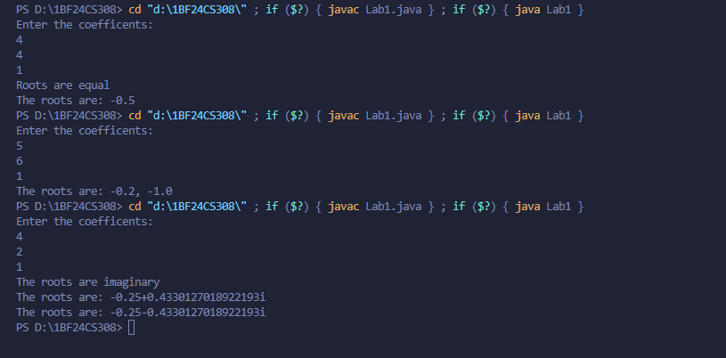

Program 2: SGPA CALCULATOR

CODE:

import java.util.Scanner;

class Student {
String name;
String usn;
int submarks[] = new int[8];
int credits[] = new int[8];
double sgpa;

void getdetails() {
Scanner s = new Scanner(System.in);
System.out.println("Enter the name: ");
name = s.nextLine();
System.out.println("Enter the usn: ");
usn = s.nextLine();
for (int i = 0; i < 8; i++) {
System.out.println("Enter the subject " + (i + 1) + "marks: ");
submarks[i] = s.nextInt();
System.out.println("Enter the credits of subject " + (i + 1) + ": ");
credits[i] = s.nextInt();
}
}

int getgrade(int m) {
if (m >= 90)
return 10;
else if (m >= 80)
return 9;
else if (m >= 70)
return 8;
else if (m >= 60)
return 7;
else if (m >= 50)
return 6;
else
return 0;
}

void getSgpa() {
double totalcredit = 0;
double totalmarks = 0;
for (int i = 0; i < 8; i++) {
totalmarks = totalmarks + (getgrade(submarks[i]) * credits[i]);
totalcredit = totalcredit + credits[i];
}
sgpa = totalmarks / totalcredit;
}

void ddisplay() {
System.out.println("NAME IS: " + name);
System.out.println("USN IS: " + usn);
System.out.println("SGPA IS: " + sgpa);
}
}

class Sgpa {
public static void main(String[] args) {
Student students[] = new Student[2];
for (int i = 0; i < 2; i++) {
Student a = new Student();

a.getdetails();
a.getSgpa();
students[i] = a;
}
for (int i = 0; i < 2; i++) {
students[i].ddisplay();

}
}
}

Output:
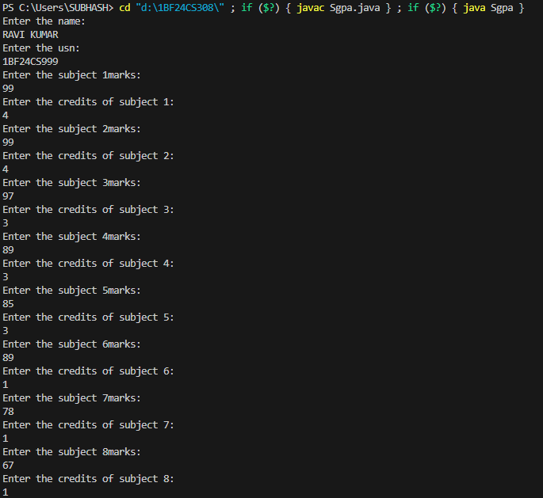

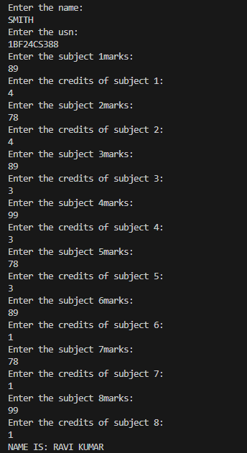

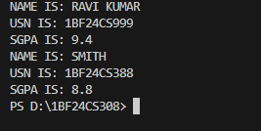

Program 3: BOOK DETAILS

CODE:

import java.util.Scanner;

class Books {
String name;
String author;
int price;
int numPages;

Books(String name, String author, int price, int numPages) {
this.name = name;
this.author = author;
this.price = price;
this.numPages = numPages;
}

public String toString() {

String name, author, price, numPages;
name = "Book name: " + this.name + "\n";
author = "Author name: " + this.author + "\n";
price = "Price: " + this.price + "\n";
numPages = "Number of pages: " + this.numPages + "\n";
return name + author + price + numPages;

}

}

class Book_details {
public static void main(String[] args) {
Scanner s = new Scanner(System.in);
int n;
String name;
String author;
int price;
int numPages;
System.out.println("Enter number of books: ");
n = s.nextInt();
Books b[] = new Books[n];
for (int i = 0; i < n; i++) {
System.out.println("Enter the name: ");
name = s.next();
System.out.println("Author of the book: ");
author = s.next();
System.out.println("Enter the price of the book: ");
price = s.nextInt();
System.out.println("ENTER THE NUMBER OF PAGES: ");
numPages = s.nextInt();
b[i] = new Books(name, author, price, numPages);
}
for (int i = 0; i < n; i++) {
System.out.println(b[i]);
}
}
}

Output:

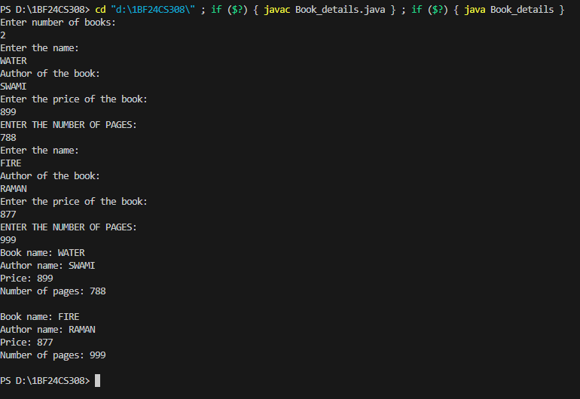

Program 4: CALCULATE AREA OF SHAPES

CODE:

import java.util.Scanner;
abstract class Shape{
double a;double b;
Shape(double w,double f){
a=w;b=f;
}
Shape(double r){
a=r;
}
abstract void print_area();
}
class Rectangle extends Shape{
Rectangle(double l,double w){
super(l,w);
}
void print_area() {
System.out.println("The area of the Rectangle is :"+a*b);
}
}
class Triangle extends Shape{
Triangle(double h,double b){
super(h,b);
}
void print_area() {
System.out.println("The area of the Triangle is :"+a*b*0.5);
}
}
class Circle extends Shape{
Circle(double r){
super(r);
}
void print_area() {
System.out.println("The area of the Circle is :"+a*a*(22/7));
}
}
public class Lab4 {
public static void main(String[] args) {
double length,width,base,height,radius;
Scanner s=new Scanner(System.in);
System.out.println("Enter the length and width of the rectangle: ");
length=s.nextDouble();
width=s.nextDouble();
System.out.println("Enter the base and height of the triangle: ");
base=s.nextDouble();
height=s.nextDouble();
System.out.println("Enter the radius of the circle: ");
radius=s.nextDouble();
Rectangle r=new Rectangle(length,width);
Triangle t=new Triangle(height,base);
Circle d=new Circle(radius);
r.print_area();
t.print_area();
d.print_area();
}
}

Output:

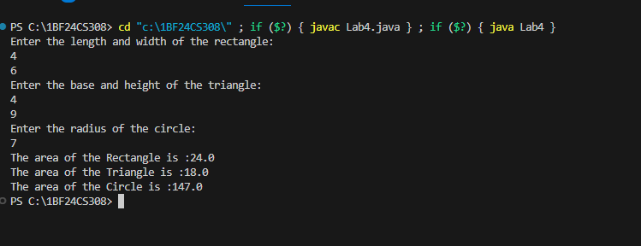

Program 5: BANK ACCOUNT

CODE:

import java.util.Scanner;
class Account{
String customer_name;int acc_no;String type;
Account(String n,int a){
customer_name=n;acc_no=a;
}
}
class Savings_Account extends Account{
double balance=0;double rate=0.05;double time_in_years=0.25;

Savings_Account(String name,int a){
super(name,a);
super.type="savings";}
void compute_interest(){
System.out.println("The interest earned is: "+balance*(rate/time_in_years));
balance=balance+(balance*(rate/time_in_years));
System.out.println("The balance is: "+balance);
}
void deposit(double d){
balance=balance+d;
}
void withdraw(double w){
balance=balance-w;
}
void display(){
System.out.println("Customer name: "+customer_name);
System.out.println("Account number is: "+acc_no);
System.out.println("Type of account is: Savings");
System.out.println("Balance is: "+balance);
}

}

class Current_Account extends Account{
double balance=0;double service_charge=150;double min_balance=3000;
Current_Account(String name,int a){
super(name,a);super.type="current";}

void deposit(double d){
balance=balance+d;
}
void check_balance(){
if(balance<min_balance){
System.out.println("Balance is less than minimum balance service charge deducted");
balance=balance-service_charge;
}
}
void compute_interest(){
System.out.println("This facility not available.");
}
void withdraw(double w){
balance=balance-w;
check_balance();
}
void display(){
System.out.println("Customer name: "+customer_name);
System.out.println("Account number is: "+acc_no);
System.out.println("Type of account is: CURRENT");
System.out.println("Balance is: "+balance);
}
}
public class Lab5 {
public static void main(String[] args) {
int q;String type;int accno;double deposit;double withdraw;
String qwe="Savings";String lwe="Current";
Scanner s=new Scanner(System.in);
String name;int accno1;int l;
Account[] a=new Account[2];
Savings_Account[] we=new Savings_Account[2];
Current_Account[] r=new Current_Account[2];
for(int i=0;i<2;i++){
System.out.println("Enter the name: ");
name=s.nextLine();
System.out.println("Enter the accno: ");
accno=s.nextInt();
a[i]=new Account(name,accno);
we[i]=new Savings_Account(name, accno);
r[i]=new Current_Account(name, accno);
s.nextLine();
}
for(int i=1;i>0;i++){
System.out.println("\n1.Withdraw 2.Deposit 3.Compute interest for savings account 4.Display account details 5.EXIT");
System.out.println("Enter the choice: ");
q=s.nextInt();
if(q==5){
System.exit(0);}
s.nextLine();
System.out.println("Enter the type of account: ");
type=s.nextLine();
if(type.equalsIgnoreCase(qwe)){
System.out.println("Enter the accno: ");
accno1=s.nextInt();
for(l=0;l<2;l++){
if(accno1==we[l].acc_no){

break;
}
}
switch(q){
case 1:
System.out.println("Enter the withdraw: ");
withdraw=s.nextDouble();
we[l].withdraw(withdraw);
break;
case 2:
System.out.println("Enter the deposit: ");
deposit=s.nextDouble();
we[l].deposit(deposit);
break;
case 3:
we[l].compute_interest();
break;
case 4:
we[l].display();
break;
}
}
else if(type.equalsIgnoreCase(lwe)){
System.out.println("Enter the accno: ");
accno1=s.nextInt();
for(l=0;l<2;l++){
if(accno1==r[l].acc_no){

break;
}
}
switch(q){
case 1:
System.out.println("Enter the withdraw: ");
withdraw=s.nextDouble();
r[l].withdraw(withdraw);
break;
case 2:
System.out.println("Enter the deposit: ");
deposit=s.nextDouble();
r[l].deposit(deposit);
break;
case 3:
r[l].compute_interest();
break;
case 4:
r[l].display();
break;

}
}
}
}}

OUTPUT:

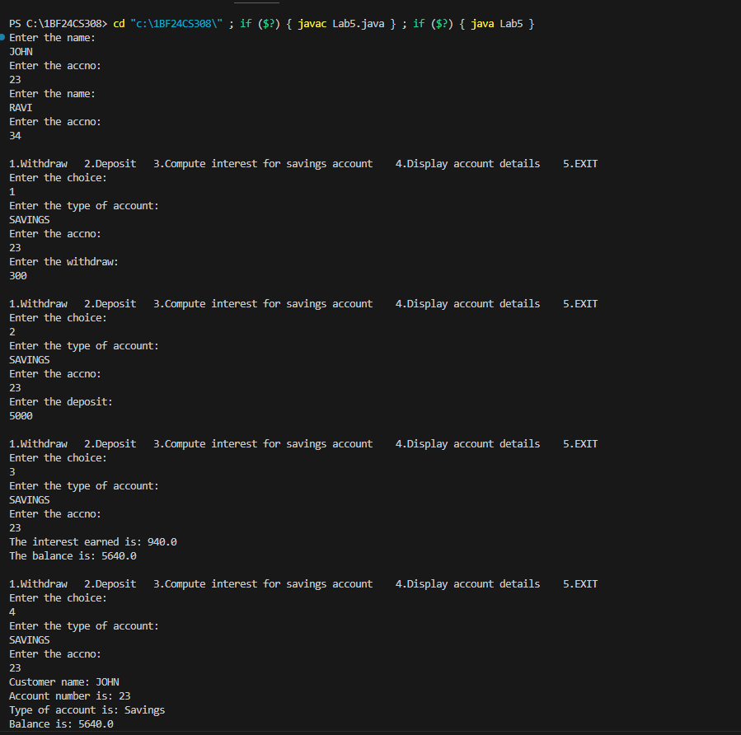

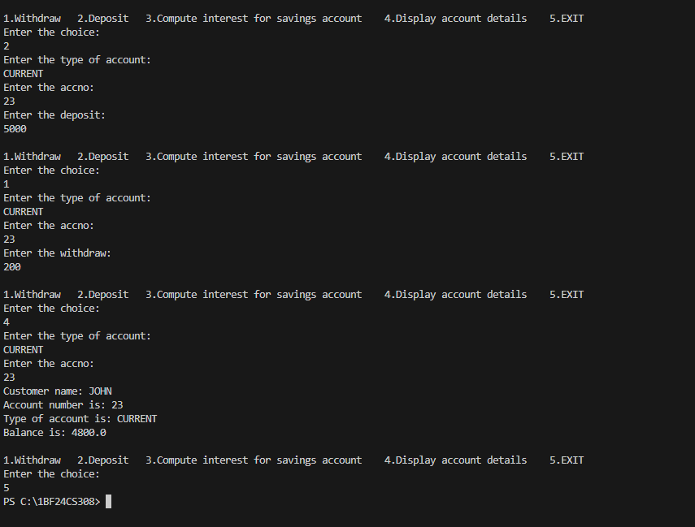

Program 6: FINAL SEE AND CIE MARKS

CODE:

package Cie;
import java.util.Scanner;
public class Internals extends Student {
protected int marks[] = new int[5];

public void inputCIEmarks(){
Scanner s=new Scanner(System.in);
for(int i=0;i<5;i++){
System.out.println("Enter the subject "+(i+1)+" marks: ");
marks[i]=s.nextInt();
}
}
}

package Cie;
import java.util.Scanner;
public class Student {
protected String usn = new String(); protected String name = new String(); protected int sem;
public void input_details(){
Scanner sc=new Scanner(System.in);
System.out.println("Enter the name: ");
name=sc.nextLine();
System.out.println("Enter the usn: ");
usn=sc.nextLine();
System.out.println("Enter the sem: ");
sem=sc.nextInt();
}
public void display(){
System.out.println("Name of the student is: "+name);
System.out.println("USN is: "+usn);
System.out.println("SEM is: "+sem);
}
}

package SEE;
import java.util.Scanner;
import Cie.Internals;
public class Externals extends Internals{
protected int marks[];

protected int finalMarks[];
public Externals(){
marks=new int[5];finalMarks=new int[5];
}
public void inputSEEmarks(){
Scanner s=new Scanner(System.in);
for(int i=0;i<5;i++){
System.out.println("Enter the subject "+(i+1)+" marks: ");
marks[i]=s.nextInt();
}
}
public void calculateFinalMarks(){

for(int i=0;i<5;i++){
finalMarks[i]=marks[i]+super.marks[i];
}
}
public void display_marks(){
super.display();
System.out.println("The final marks in all 5 courses are: ");

for(int i=0;i<5;i++){
System.out.println("Course "+(i+1)+" is: "+finalMarks[i]);
}
}
}

import SEE.Externals;
class Lab6{
public static void main(String[] args) {
Externals we=new Externals();
we.input_details();we.inputCIEmarks();we.inputSEEmarks();we.calculateFinalMarks();
we.display_marks();

}}

OUTPUT:

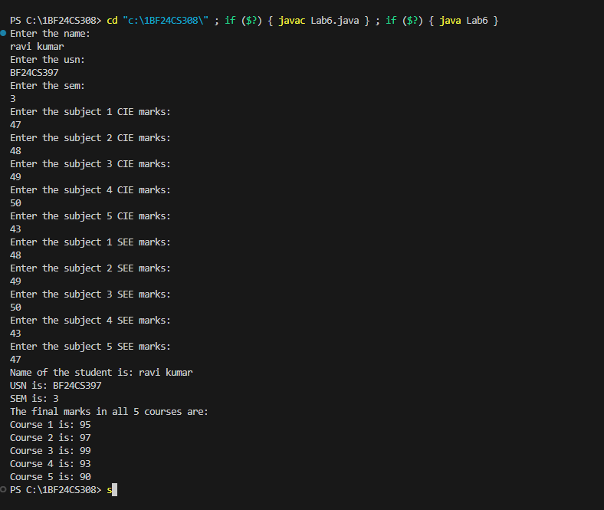

PROGRAM 7: WRONG AGE

CODE:

import java.util.Scanner;

class WrongAge extends Exception {
public WrongAge(String msg) {
super(msg);
}
}

class InputScanner {
Scanner sc = new Scanner(System.in);
}

class Father extends InputScanner {
int father_age;

public Father() throws WrongAge {
System.out.println("Enter the father's age: ");
father_age = sc.nextInt();
if (father_age < 0) {
throw new WrongAge("Age cannot be negative");
}
}

public void display() {
System.out.println("The father's age is: " + father_age);
}
}

class Son extends Father {
int son_age;

public Son() throws WrongAge {
System.out.println("Enter the son's age: ");
son_age = sc.nextInt();
if (son_age < 0) {
throw new WrongAge("Age cannot be negative");
} else if (son_age >= father_age) {
throw new WrongAge("Son's age cannot be greater than father's age");
}
}

public void display() {
super.display();
System.out.println("The son's age is: " + son_age);
}
}

public class Lab7 {
public static void main(String[] args) {
try {
Son s = new Son();
s.display();
} catch (WrongAge e) {
System.out.println(e.getMessage());
}
}
}

OUTPUT:

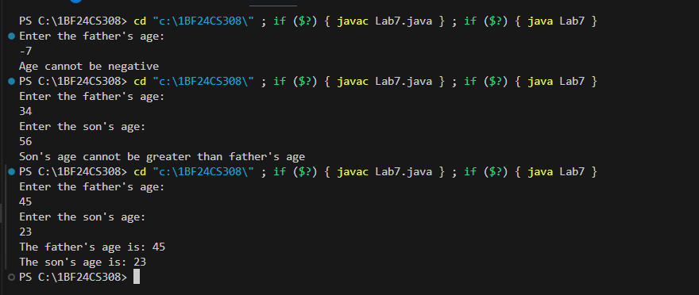

PROGRAM 8: MULTITHREADING

CODE:

class College_Thread extends Thread{
public void run(){
try{
while(true){
System.out.println("BMS COLLEGE OF ENGINEERING");
Thread.sleep(10000);
}

} catch (InterruptedException e) {
System.out.println("COLLEGE THREAD INTERRUPTED");
}
}
}
class Cse_Thread extends Thread{
public void run(){
try{
while(true){
System.out.println("CSE");
Thread.sleep(2000);
}
} catch (InterruptedException e) {
System.out.println("CSE THREAD INTERRUPTED");
}
}
}
class Lab8{
public static void main(String[] args) {
College_Thread t1=new College_Thread();
Cse_Thread t2=new Cse_Thread();
t1.start();t2.start();
}
}

OUTPUT:

